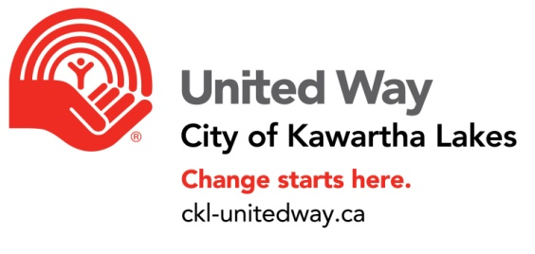
UW Agency Supplementary Fundraising Form

Please submit this form 60 Days in advance of your event.

Name of Agency:

Contact person: Position:

Date of Event: Is this a third party event?

If yes, please provide name of 3rd Party host:

Name of Third Party Contact

Proposed Activity:

Projected Dollar Amount to be raised

Start Date of Active Promotion:

Promotional Methods:

Other Comments:

By signing below, the agency agrees that the full amount raised will be given to the United Way CKL (cheque made out to UW from 3rd Party organizer). Fifty percent of proceeds will be immediately designated to the agency.

Name of Agency Representative (Please Print) ___________________

Signature of Agency Representative: _______________________ Date:____________

Signature of Third Party Organizer: _________________________ Date: ___________

UW Office Use:

Date Received:______________ Date Approved By Board: _________________

UW Authorized Signature: _________________________

