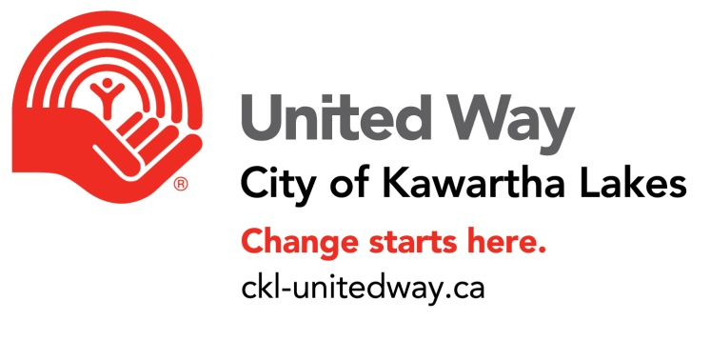
Funding Criteria-New agency and programs

The United Way for the City of Kawartha Lakes is committed to helping improve lives by engaging people and working together. Your United Way has been offering help and hope for people in real time for 50 years. To make greater impact and to address systemic issues in our communities, three strategic pillars have been identified. The following criteria must be met to apply:

- Alignment with the United Way pillars: Poverty to Possibility, All that Kids Can Be and Healthy Communities, Strong People.
- Agency primary function is to provide services in response to current and emerging needs in the City of Kawartha Lakes
- Operates with a voluntary Board of Directors which is representative of the community it serves and reflects the main interests of the organization’s field of work.
- Agencies requesting funding must be in good standing with Revenue Canada. Several documents of support are required –see the application.
- The agency has board approval to make the request.
- The agency agrees to participate in the funding allocation review process which includes agency site visits and meetings with board representatives, staff and UW Citizen Review Panel members.
- Agency acknowledges and agrees that in the event operations cease, the UW funds will be withdrawn and returned.
- Multi geographic jurisdiction agencies must be able to clearly demonstrate the United Way CKL funding is used exclusively for programs and services within the boundaries of the City of Kawartha Lakes or as designated by donors to certain programs and locations in Haliburton. Funding for Haliburton programs at this time are only through designations by donors.
- Cooperate with other community agencies to prevent duplications and make a sincere effort to consider the community’s overall needs in planning programs. Programs that are duplication in services are not eligible for funding through United Way CKL.
- Honour the ‘Agency Agreement’ with the United Way for CKL which includes public and financial support of the fundraising campaign and supplementary fundraising activities.
Funding applications are posted to the United Way website at the beginning of December each year. Only completed applications are accepted until February 1 of the funding year. Applicants will be advised in late April of their funding status.

